**GIT LAB ASSESSMENT-1**

NAME : SRIMUGHI S

REG NUMBER : 731621104052

BRANCH : BE

DEPARTMENT : COMPUTER SCIENCE ENGINERRING

YEAR : IV

COLLEGE NAME: KSRIET

DATE : 11.07.2024

1. Create a local git repo with the name "My Repo":



2. Create one .txt file, five .c files and five .java files in the working area:

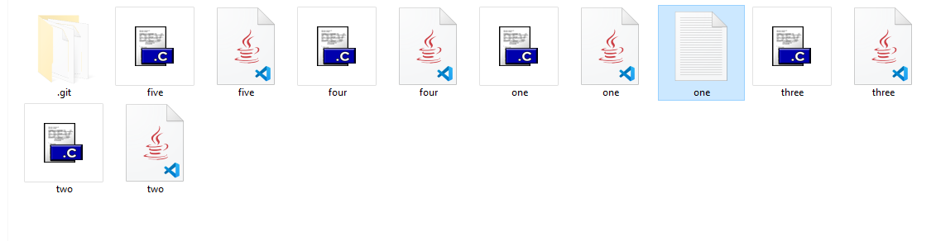

3. Verify the git status:

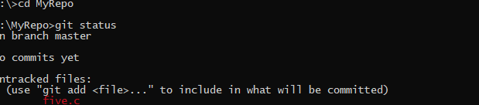

4. Add only the .txt into the staging area:

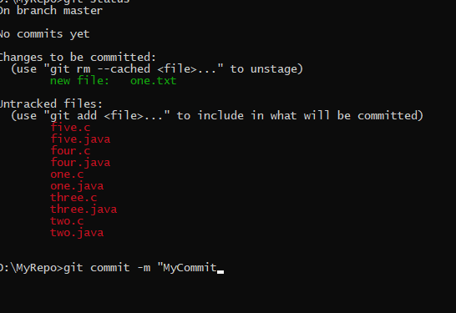

5. Verify the git status:

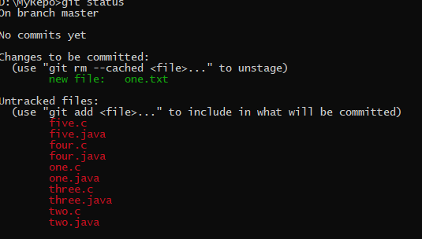

6. Make a commit with the name "TXT Commit":

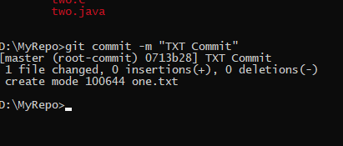

7. Add all .c files into the staging area:

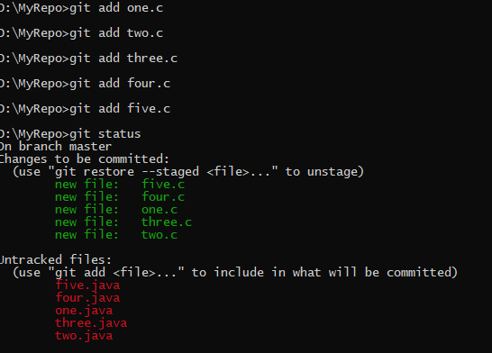

8. Verify the git status:

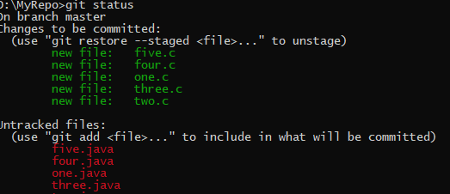

9. Make a commit with the name "C Commit":

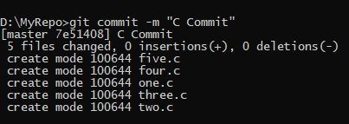

10 .Add all .java files into the staging area:

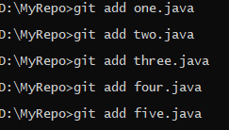

11. Verify the git status:

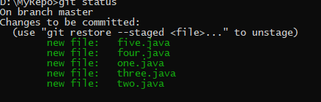

12. Make a commit with the name "Java Commit":

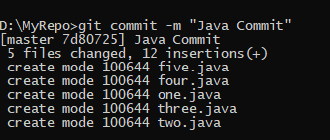

13. Delete all .java files from working area:

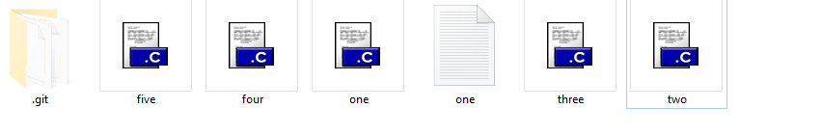

14. Now see the status:

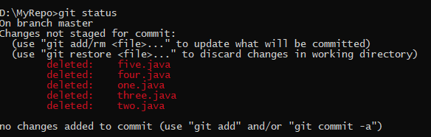

15. Add the changes into the staging area:

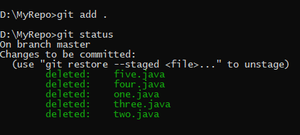

16. Make a commit with the name "Delete Java Commit":

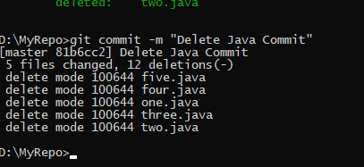

17. Display all commit details:



